ASSIGNMENT 4

|  |  |
| --- | --- |
| Date | 12 November 2022 |
| Team ID | PNT2022TMID18149 |
| Project Name | NUTRITION ASSISTANT APPLICATION |

Question-1:

pull an image from docker hub and run it in docker playground.

pull an image form docker hub run it in docker playground

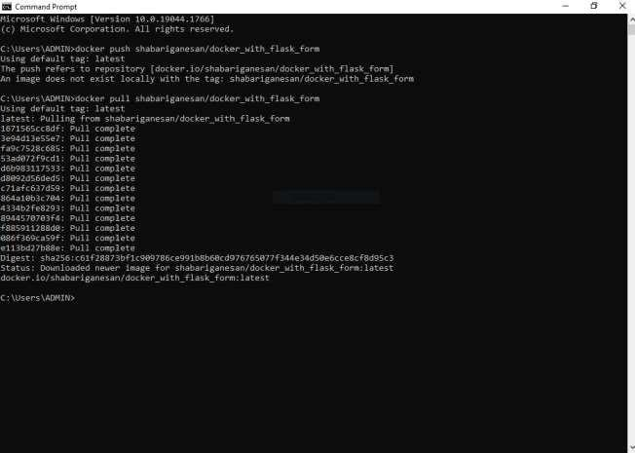

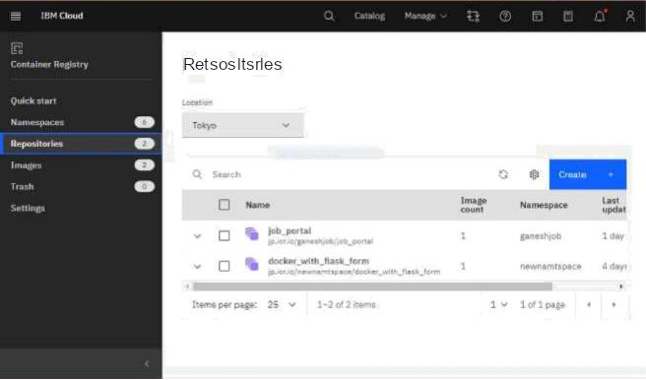

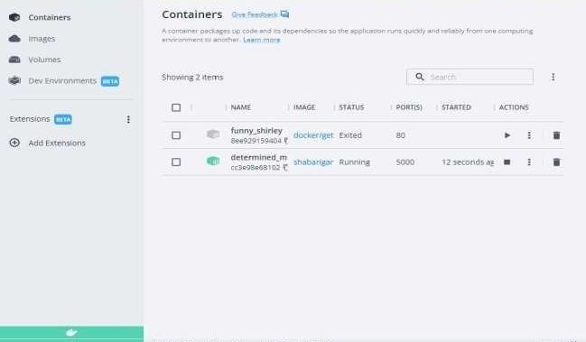

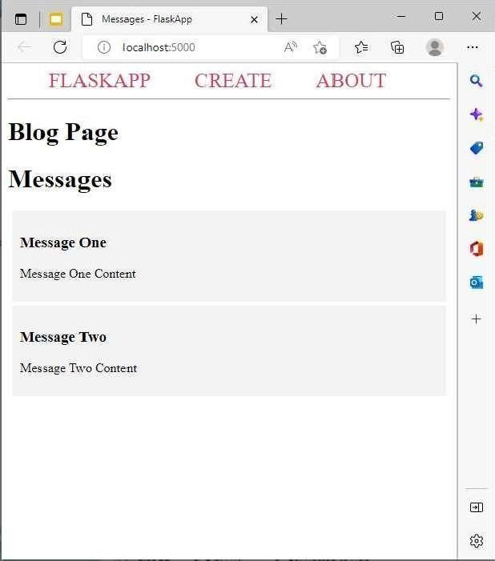

Question-2:

Create a docker file for the jobportal application and deploy it in docker application.

Creating a docker file for the jobportal application

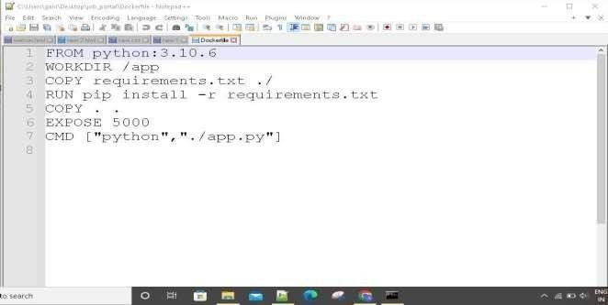

deploy in in dokcer application

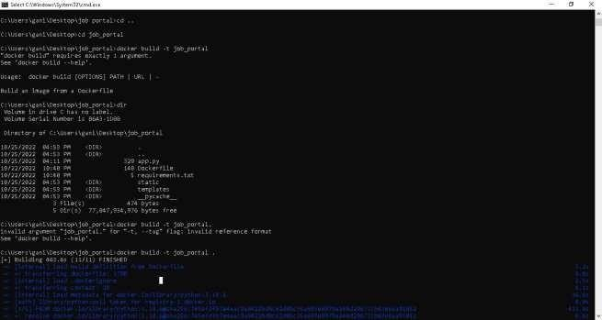

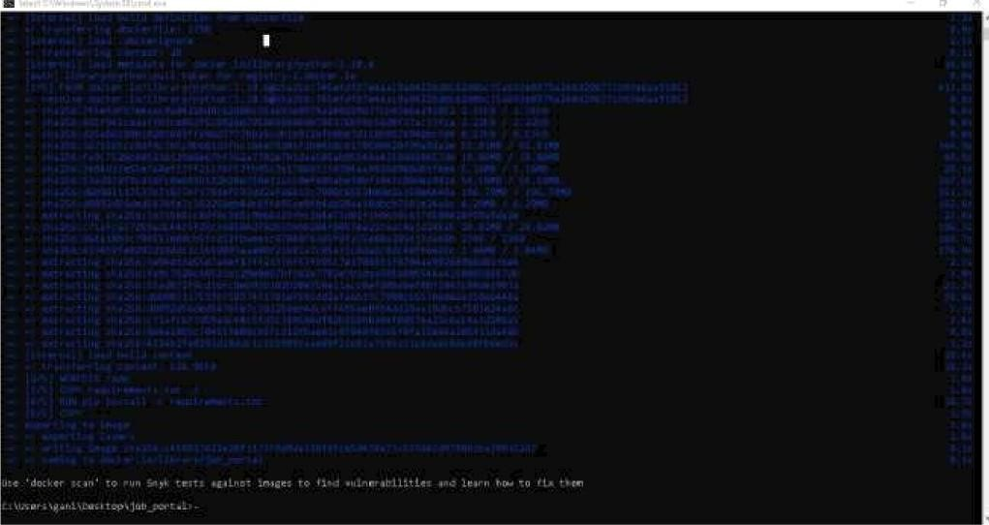



C c rat ¿z i n e r S 



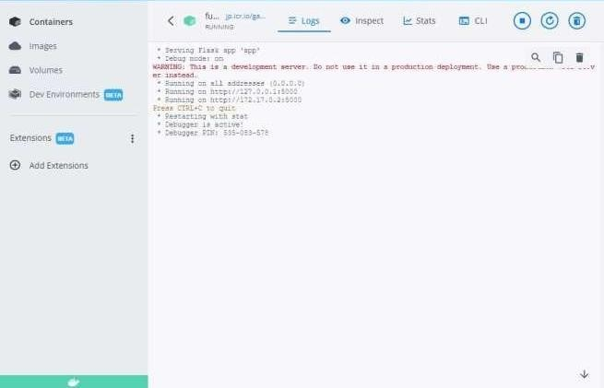

# running in docker desktop 1

Question-3:Create aIbm container registry and deploy helloworld app or jobportalapp create a ibm container registry



deployhelloworld or jobportal

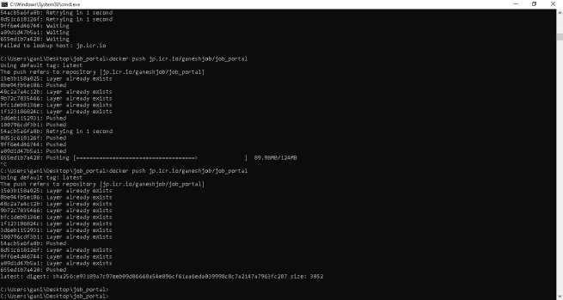



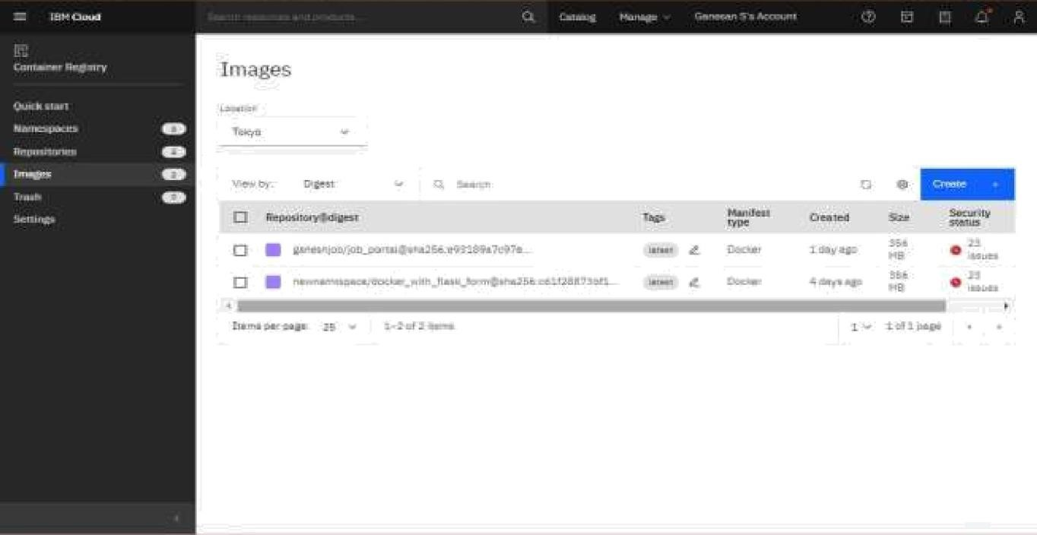

Question-4: Create a kubernetes cluster in ibm cloud and deploy helloworld image or jobportal image and also expose the same app to run in noteport

Creating a kubernetes cluster in ibm cloud

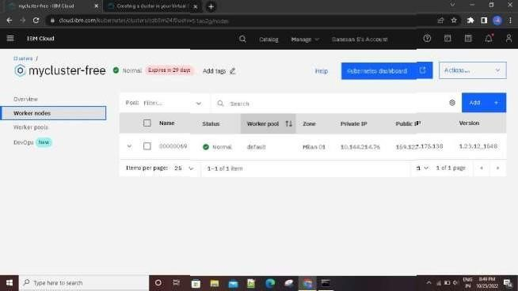

deploy helloworld image or jobportal image and also expose the same app to run in noteport

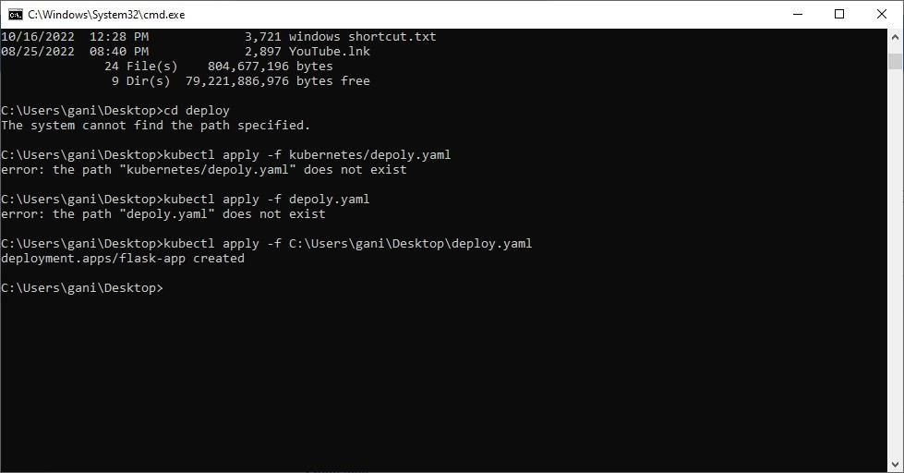







 Wa1lin-g for more da la a display c har l... Wa li ng for more data a di splay chart...





 



 





